

GENERAL TRAINING PROPOSAL

|  |
| --- |
|  |
|  |
| March 10  BY JOSEPH O. T. ODUSANYA, PhD |



**Contents**

Executive Summary

Introduction

About Us

Our Distinctives

Our Services

Training Approach

Program Deliverables

Investment & Pricing

Meet the Team

Signatures

Appendix

* General Course Listing
* Details of Our Consultants

**EXECUTIVE SUMMARY**

At Joseph Odusanya & Associates (JOA), we specialize in delivering high-impact, workshop-based training programs designed to enhance workforce productivity, leadership skills, and business efficiency. This proposal outlines our training approach, course offerings, methodologies, and the value we bring to your organization.

Through our extensive JOA Training Library, we provide a wide range of courses covering essential workplace skills, leadership development, problem-solving, HR management, finance, marketing, and technical skills. Our programs cater to different levels of expertise, from foundational knowledge to advanced professional training.

Key highlights of this proposal include:

• Customized Training Solutions: We align our courses with your organization’s specific needs, ensuring relevance and practical application.

• Interactive Workshop Format: Our hands-on, experiential learning approach fosters engagement and skill retention.

• Expert-Led Training: Our facilitators are industry professionals with extensive local and international experience.

• Comprehensive Course Offerings: From Microsoft Suite essentials to strategic leadership, sales excellence, and financial acumen, we provide a holistic training experience.

• Measurable Outcomes: Our programs are designed to enhance employee performance, leadership effectiveness, and business efficiency.

This document details our training methodology, expected deliverables, timelines, and investment requirements. We are committed to equipping your workforce with the tools needed to thrive in today’s dynamic business environment.

**INTRODUCTION**

The success of any organization depends on the knowledge, skills, and efficiency of its workforce. In a rapidly evolving business landscape, continuous professional development is essential for staying competitive. At Joseph Odusanya & Associates (JOA), we are committed to providing world-class training solutions that empower individuals and organizations to achieve their full potential.

Our training programs are designed to bridge skill gaps, enhance leadership capabilities, and improve workplace efficiency. We focus on practical, results-oriented learning delivered through interactive workshops that ensure participants gain real-world, applicable skills.

The JOA Training Library offers a diverse range of courses tailored to meet industry demands, including:

• Leadership & People Management – Developing strong, adaptable leaders.

• Technical & IT Skills – Training in essential software and analytical tools.

• HR & Workplace Excellence – Enhancing organizational culture and performance.

• Finance & Business Strategy – Equipping teams with financial literacy and strategic decision-making skills.

• Sales & Marketing Excellence – Driving business growth through customer engagement and sales effectiveness.

This proposal outlines the structure, methodology, and value of our training programs. Whether your organization is looking to improve management skills, increase efficiency, or foster innovation, we offer the expertise and training solutions needed to achieve your goals.

**ABOUT US**

Joseph Odusanya & Associates is a psychologist-led, multidisciplinary, and multinational business and management solutions consulting firm. We assist organizations and their leaders in designing and implementing business solutions that help their people make the best use of the organization’s resources. We view good results as a legitimate expectation of your people’s hard work, which they rightly deserve, and we therefore partner with them to make that happen. We assist organizations at the individual, group, and organization-wide levels, regardless of size, in realizing their strategy through their people, structures, and processes. Through our versatile and diverse team, we offer end-to-end advisory services and customized solutions to meet your unique needs.

Expertise

Our experience base includes not only local signature clients, but also (through our network of strategic partnerships) international best-in-class partners, including market and brand leaders.

We have considerable experience in working with clients to improve business results by assessing the potential and capabilities of key position holders and leaders within organizations. Our experience includes successful projects in operational organizations where rapid growth has outstripped management development and where there is a need to improve management ability if growth is to be sustained.

As well as understanding management assessment and development from a strategic perspective, we have a practical understanding of how to design and deliver all kinds of assessment programs to ensure maximum ownership from the target audience. Our consultants are used to tailoring such programs to specific needs, using a range of tools including the ‘tried and tested’ and the innovative. They also know when to tailor and adapt, and when to insist upon retaining the integrity of a complete approach.

* We are a reliable consultancy in the area of life and work life coaching because we coach with data and our methodologies are contemporary, rigorous, based on peer-reviewed research that are on-going and practical in nature.
* Our work with clients shows that we believe in transferring skills and knowledge to our clients as part of successful consulting interventions. Our client satisfaction reviews show how we have worked successfully with clients to increase their skills base and to equip them to maintain and improve the results achieved in our work with them. In this project we make the assumption that Pinnacle will see value to have key personnel trained in order to work alongside her future colleagues as a coaching and productivity resource.
* Finally, in this intervention, we offer off-site possibilities within Lagos state, in other states within Nigeria, Overseas in South Africa, within the USA, in Europe or a unique experience in the Asia-pacific, where we have very uncommon experience.

Our Clients



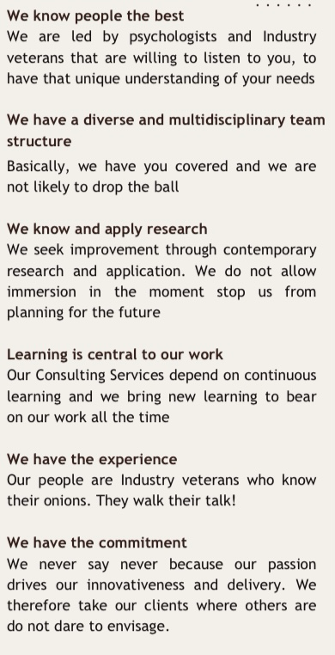**OUR DISTINCTIVES**

**OUR SERVICES**

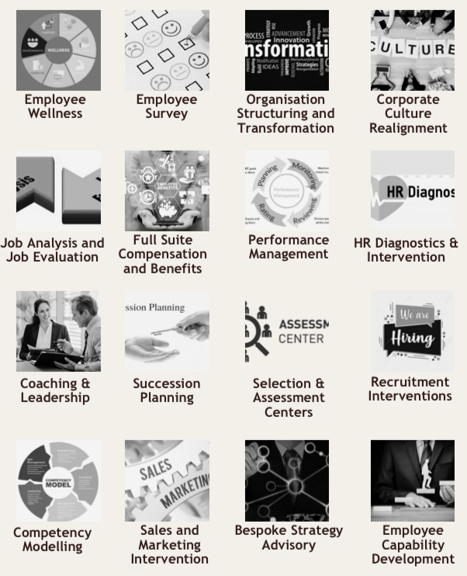

**OUR SERVICES**

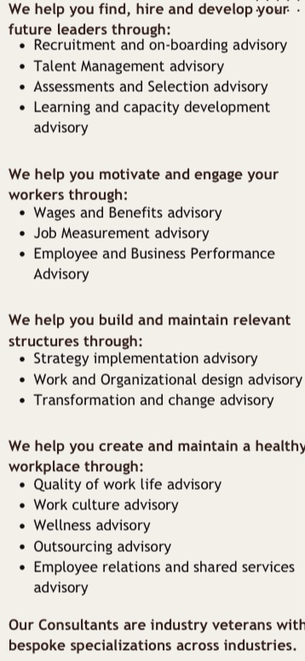

**TRAINING APPROACH**

In developing our approach to this proposal, we have drawn together our extensive experience of working with individuals and executives in other world-class companies to create and maintain the level of leadership capability that enables the business to deliver its strategic intent. This experience has enabled us to develop a set of critical success factors, which allow for rapid deployment. In this case, the success factors certainly should the subjects preferences, which we would have been familiar with and will have further opportunities to leverage. Additionally, any coaching and life advisory we provide should meet the following conditions:

* Must not only be fair and objective: it must be seen by all stakeholders to be fair and objective.
* For the participants, the reputation of the overall process, and indeed of the ‘total experience’, must be perceived as a career builder, and not as a career limiter, irrespective of the outcome of individual assessments deployed. (i.e., all participants in our life and work coaching sessions should feel empowered at all times in the process).
* The content, climate and staffing of the coaching process must reflect the high standards that your company is known for, therefore, candidates have to feel valued and impressed, as well as self-motivated to be involved.
* The process has to lead to a set of focused and grounded actions that can inform future development and application on the job and in their personal lives, thus our focus on problem solving.
* Your company’s topmost- and senior staff need to be clear about the implications of the process for ‘their’ individuals, even as the process guarantees participants ultimate confidentiality.
* The coaching process has to reflect the full weight and organizational relevance of the ‘coaching immersion model’ upon which it is based.

All the factors above can be addressed within the confines of the technical design and delivery of the process. We are therefore, essentially proposing two parts to this coaching design, namely: A problem solving and coaching immersion development and Intervention on one hand, to be completed off-site (in any chosen location within Nigeria or Internationally in Ghana, South Africa, USA, Around the Alps, e.g., South of France, Austria, Malaysia or Singapore) and an on the job coaching application part through which the participant experiences will be monitored over a period of twelve weeks, which will be achieved on the job, back in Lagos.

Our technical approach and methodology

Our overarching coaching approach incorporates many proven methodologies.

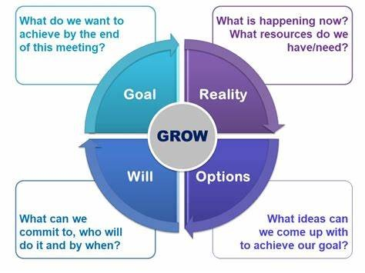Firstly, we will rely on the well accepted GROW coaching model.

Here, we will help participants set clear goals, then in a cyclical way, to understand their current reality, then, explore options towards their goals, and then commit them to actionable steps. The model is neither rigid nor static and it recognizes that there can be oscillations in the process as life events unfold. However, with co-coaching led by a professional coach, the participants are soon guided to make progress on the model.

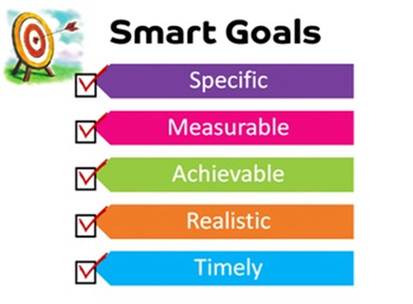Secondly, we will rely on yet another simple and well known accepted framework…

The SMART goal-setting framework.

Our co-coach will work together to set SMART goals that are Specific, Measurable, Achievable, Relevant, and Time-bound at every step of the interaction.

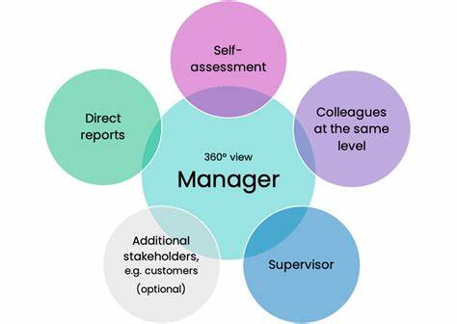We would normally make use of any available 360 degree feedback tool available, and so would happily solicit any recent data that is available within the system or be quite happy to conduct a fresh one for the your company. We shall deploy it thus, in this scenario.

Our rationale here is simple. In coaching, by gathering feedback from various stakeholders, we will gain a comprehensive understanding of our participant’s performance and areas for improvement.

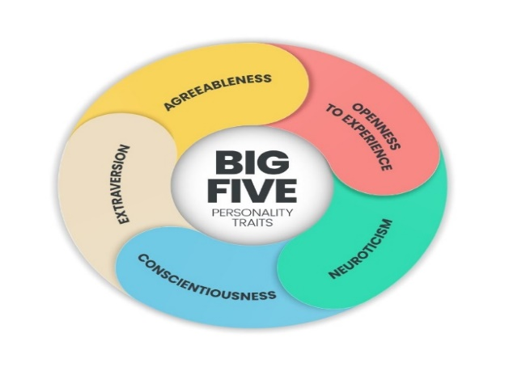We will also augment the data gathering with an objective tool that provides insights into the personality and preferences of the participant. For this we have chosen to use the five factor personality assessment tool.

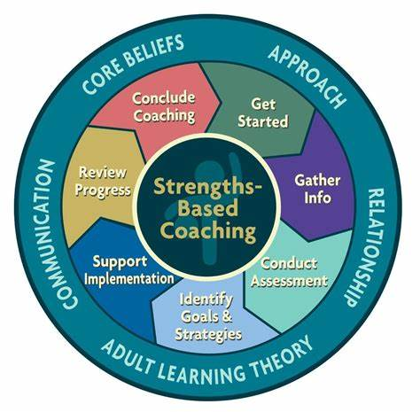From our many years of experience we have realized that every individual has strengths that we can always leverage to advantage.

This way, we shall assist our participants to overcome their challenges and make rapid progress towards their stated goals. In this coaching approach, therefore, we will rely on Strengths-Based coaching as a companion and prominent prompt.

The expected outcomes of this intervention

Our problem solving and coaching work is expected to harness the enthusiasm of the participant and bring about satisfaction that will translate into success in their personal and work lives. Specifically, we will have the following as specific outcomes;

1. Sustainable and Transferrable Problem Solving capability: This will immediately impact the job at hand and supervision of colleagues.
2. Develop Coaching Skills: This will equip participant with the skills and knowledge to become effective coach in their own right.
3. Enhance Personal Development: This will foster individual growth and productivity through personalized coaching and co-coaching immersion.
4. Sustainable Transformation: This will ensure long-term improvement by integrating coaching outcomes into the participants’ daily work environment.

These will be delivered in the two main parts highlighted earlier:

Part one: Off-site training on problem solving, work and life co-coaching immersion

Part two: Follow up on-the-job transformation coaching reviews of about three months.

A confidential report will be generated for each of the participants at the very end of the process. The report so generated is expected to form an invaluable part of the participants’ future development orientation.

**PROGRAM DELIVERABLES**

Training Workshop in Progress

A professional setting where  
employees are actively engaged in a hands-on workshop with a facilitator guiding them.

Group Discussion & Collaboration

Participants working together on problem-solving exercises, showcasing teamwork and engagement.

Performance Assessment &  
Feedback

A one-on-one coaching or mentoring session where an expert trainer is providing feedback to a participant.



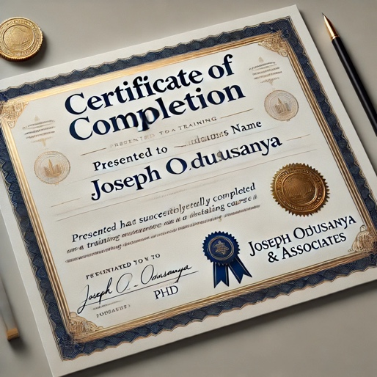

Certificate Presentation

Employees receiving certificates of completion, symbolizing  
achievement and program success.

Post-Training Support & Follow-Up

A virtual or in-person meeting where a consultant is providing follow-up guidance to ensure learning applications.

**INVESTMENT & PRICING**

Estimated fees for our professional services are as follows:

|  |  |  |  |  |
| --- | --- | --- | --- | --- |
| PART 1 | DESCRIPTION | DELIVERABLES | DURATION | YOUR IINVESTMENT |
| 1 | Project set up and contracting | * Project sign off * Confirmation of all bookings * Psychometric tools deployed | 1-2 days | N10,000,000 |
| 2 | Coaching training | Off-site work and life co-coaching training immersion   * Strengths and development opportunities clearly identified and discussed * Training certification | 4 days | N42,000,000  -  N218,000,000 |
| Sub total | | | | Depending on choices made |
| PART 2 | DESCRIPTION | DELIVERABLES | DURATION | YOUR IINVESTMENT |
| 1 | Follow up reviews | * Weekly follow-up coaching review sessions with coach * Weekly goal setting and previous week’s review | 12 sessions | N300,000/pax/session |
| 2 | Project wrap up | * Comprehensive personal assessment report presented to participant in confidence. * Strengths and development areas further amplified * Possible future personal goal setting facilitated in closing session | 3 day | N800,000/Pax |
| 3 | Reporting to your Company | * Executive summary. Presentation, discussions, with recommendations. | 2 days | No charge |
| Sub total | | | | Depends on choices made |

Depending on the location that is eventually chosen, either locally in Lagos, within Nigeria, or internationally, separate invoices will be generated for each tax jurisdiction as is appropriate. All payments will be received on time in Naira. All facilitation materials and venues including posters, electronic facilities, and servicing will be organized by JOA.

Further Terms and Conditions

1. Your company will be responsible for travel, room, and board of their nominees.
2. Each session will welcome a cohort of 3, 6, 9 or maximum of 12 participants per round. Decision will come from discussion and negotiation
3. The total cost of Part one and 60% of part two are due before commencement.
4. All additional, but agreed expenses in advance, such as travel and accommodation for all JOA consultants will be borne by your company.
5. Pricing in this quotation is valid for three months after quotation and agreement.
6. All segments of this proposal are open to be discussed and negotiated prior to invoicing, however, all invoices are due on presentation.

**MEET THE TEAM**

Who will work with you?

Joseph O. T. Odusanya and Gary Norton will lead this work with you, on this assignment and their resumes are summarized in this proposal as an appendix. They will be assisted with other qualified consultants as necessary depending on the eventual locations chosen and timing considerations.

**SIGNATURES**

Please append your signature below to signify acceptance of this proposal.



For

Your Company

Name

Permanent Secretary

Date

For

Joseph Odusanya & Associates

Joseph O. T. Odusanya, PhD

Managing Associate

Date

**APPENDICES**

GENERAL COURSE LISTING

JOT TRAINING LIBRARY

Essential Microsoft Suite Training

1. Access Essentials

2. Excel Essentials

3. Outlook Essentials

4. PowerPoint Essentials

5. Word Essentials

6. Excel Expert

7. Word Expert

We train in older versions and the latest software versions as well. We also train at different skill levels of beginner, intermediate, and advanced learning

Learning Skills Library

1. Accountability in the Workplace

2. Administrative Office Procedures

3. Administrative Support

4. Adult Learning - Mental Skills

5. Adult Learning – Physical Skills

6. Anger Management

7. Appreciative Inquiry

8. Archiving and Records Management

9. Attention Management

10. Basic Bookkeeping

11. Becoming a Likeable Boss

12. Body Language Basics

13. Budgets and Financial Reports

14. Building Confidence and Assertiveness

15. Business Acumen

16. Business Ethics

17. Business Etiquette

18. Business Succession Planning

19. Business Writing

20. Call Center Training

21. Change Management

22. Civility in the Workplace

23. Coaching and Mentoring

24. Coaching Salespeople

25. Collaborative Business Writing

26. Communication Strategies

27. Conducting Annual Employee Reviews

28. Conflict Resolution

29. Contact Center Training

30. Contract Management

31. Creating a Great Webinar

32. Creative Problem Solving

33. Creativity: Thinking Outside the Box

34. Crisis Management

35 .Critical Thinking

36. Customer Service

37. Customer Support

38. Cyber Security

39. Delivering Constructive Criticism

40. Developing a Lunch and Learn

41. Developing Corporate Behavior

42. Developing Creativity

43. Developing Emotional Intelligence

44. Developing New Managers

45. Digital Citizenship

46. Diversity, Equity and Inclusion

47. Employee Motivation

48. Employee Onboarding

49. Employee Recruitment

50 .Employee Termination Processes

51 .Entrepreneurship

52. Event Planning

53. Executive and Personal Assistants

54. Facilitation Skills

55. Generation Gaps

56. Goal Setting and Getting Things Done

57. Handling a Difficult Customer

58. Health and Wellness at Work

59. High Performance Teams inside the Company

60. High Performance Teams Remote Workforce

61. Hiring Strategies

62. Human Resource Management

63. Improving Mindfulness

64. Improving Self -Awareness

65. In-person Sales

66. Increasing Your Happiness

67. Internet Marketing Fundamentals

68. Interpersonal Skills

69. Job Search Skills

70. Knowledge Management

71. Leadership and Influence

72. Leadership Development for Women

73. Lean Six Sigma

74. Life Coaching Essentials

75. Manager Management

76. Managing Personal Finances

77. Managing Workplace Anxiety

78. Managing Workplace Harassment

79. Marketing Basics

80. Measuring Results from Training

81. Media and Public Relations

82. Meeting Management

83. Middle Manager

84. Millennial Onboarding

85. Learning Essentials

86. Motivating Your Sales Team

87. Multi -Level Marketing

88. Negotiation Skills

89. Networking outside the Company

90. Networking within the Company

91. Office Health and Safety

92. Office Politics for Managers

93. Organizational Skills

94. Overcoming Sales Objections

95. Performance Management

96. Personal Branding

97. Personal Productivity

98. Presentation Skills

99. Project Management

100. Proposal Writing

101. Prospecting and Lead Generation

102. Public Speaking

103. Recognizing Employee Excellence

104. Respect in the Workplace

105. Responsibility in the Workplace

106. Risk Assessment and Management

107. Safety in the Workplace

108. Sales Fundamentals

109. Self-Leadership

110. Sensitivity Training

111. Servant Leadership

112. Social Intelligence

113. Social Learning

114. Social Media in the Workplace

115. Social Media Marketing

116. Stress Management

117. Supervising Others

118. Supply Chain Management

119. Taking Initiative

120. Talent Management

121. Team Building for Managers

122. Team Building through Chemistry

123. Teamwork and Team Building124. Telephone Etiquette

125. Telework and Telecommuting

126. The Cloud and Business

127. Time Management

128. Trade Show Staff Training

129. Train-The-Trainer

130. Trust Building and Resilience Development

131. Unconscious Bias

132. Universal Safety Practices

133. Virtual Team Building and Management

134. Work-Life Balance

135. Workplace Bullying

136. Workplace Harassment

137. Work Place Violence

All the listed courses in the General Skills Library are one day delivery courses that are updated regularly. However, courses are often redesigned to choose themes or emphasis from client organizations, such that, the courses may be delivered in two or more days depending on the agreed design.

Special Learning Skills Library

1. Job Evaluation Fundamentals

2. Hay Job Evaluation Methodology

3. Job Analysis Fundamentals

4. Job Design Fundamentals

5. Compensation and Benefits

6. HR for Professionals

7. Nigerian Anti-money Laundering Regulations

8. Data Analysis and Visualization

9. Data Driven Decision Making

10. Managing Cross-Functional Projects

11. Applied Project Management

12. Communications Strategy

13. Aligning Sales and Marketing Efforts

14. Sales and Marketing Excellence

15. Making great Leaders

16. Recruitment and Selection Excellence

17. Reward Management Essentials

18. Behavioral Event Interviewing

19. Competency Based HR Systems

20. Variable Pay Design

21. Pay Equity and Market Equity

22. Expatriation and Cross-Cultural Readiness

Special Finance & Banking Skills Library

1. Basic Accounting Principles for Business

2. Financial Acumen

3. Foundations of Credit Risk Analysis & Management

4. Analyzing, Managing & Structuring Credit for Corporate Obligors

5. Analyzing, Managing & Structuring Credit for Commercial-Type Obligors

6. Credit Management & Debt Recovery

Special Marketing & Sales Skills Library

1. Effective Sales Presentation

2. Mastering Marketing

3. Fundamentals of Marketing

4. Dynamics of Customer Relationship Management

5. Developing a Customer Service Orientation

Special Marketing & Sales Skills Library

1. Fundamentals of Leadership

2. Executive Leadership

3. Adaptive Leadership and Influence Tactics

4. Building and Developing Your Teams

5. Delegating & Mentoring For Productivity

6. Key Supervisory Principles In Practice

6. Key Supervisory Principles in Practice

Special People Management Skills

1. Effective Training and Development

2. Essentials of Staff Careers Development

3. Managing Performance with Objective

DETAILS OF OUR CONSULTANTS

Joseph O. T. Odusanya, PhD

*Managing Associate*



Joseph Odusanya is Managing Associate at Joseph Odusanya and Associates, an Abuja registered, but Lagos based consultancy. He specializes in organization effectiveness and leadership development, helping their clients translate their executive and reward strategies, coaching executives for success, and providing business transformation solutions. He helps organizations work better by designing effective processes and tools to attract, motivate and retain key talent at all levels in their business.

Dedicated to Delivering Results

Joseph has delivered successful business solutions for a wide range of organizations, including Shell, British American Tobacco, Sud Chemie, Panasonic, Nigerian NLNG, NESTLE, Nigerian National Petroleum Corporation, and GOL Limited, .

His expertise spans many areas, including the design and implementation of effective practical methods to improve levels of performance motivation and delivery. He has worked with clients to develop integrated competency frameworks aligned to business strategic imperatives. A major focus of his work has been in ensuring that the business solutions designed are seamlessly integrated into practical people management practices by building capability and capacity to sustain value-add to the business. In

DETAILS OF OUR CONSULTANTS

Joseph O. T. Odusanya, PhD

*Managing Associate*



Joseph Odusanya is Managing Associate at Joseph Odusanya and Associates, an Abuja registered, but Lagos based consultancy. He specializes in organization effectiveness and leadership development, helping their clients translate their executive and reward strategies, coaching executives for success, and providing business transformation solutions. He helps organizations work better by designing effective processes and tools to attract, motivate and retain key talent at all levels in their business.

Dedicated to Delivering Results

Joseph has delivered successful business solutions for a wide range of organizations, including Shell, British American Tobacco, Sud Chemie, Panasonic, Nigerian NLNG, NESTLE, Nigerian National Petroleum Corporation, and GOL Limited, .

His expertise spans many areas, including the design and implementation of effective practical methods to improve levels of performance motivation and delivery. He has worked with clients to develop integrated competency frameworks aligned to business strategic imperatives. A major focus of his work has been in ensuring that the business solutions designed are seamlessly integrated into practical people management practices by building capability and capacity to sustain value-add to the business. In addition, Joseph has successfully assisted executive committees, management, staff and unions to come to a common understanding of the relative worth and sizes of jobs within their organizations.

Specialized Expertise for Specialized Needs

Joseph has created and facilitated programs in leadership, executive coaching and capability development, competency-based selection systems, organizational unions to come to a common understanding of the relative worth and sizes of jobs within their organizations.

Specialized Expertise for Specialized Needs

Joseph has created and facilitated programs in leadership, executive coaching and capability development, competency-based selection systems, organizational development, talent management, and performance management. In addition to working with clients in Nigeria, Joseph also has extensive experience with organizations in greater Africa, and the Asia-pacific realms.

Joseph’s Education and Affiliations

Prior to founding Joseph Odusanya & Associates, Joseph worked in senior management positions within Nigeria as Global Head of Human Capital at Keystone Bank and as Chief Human Resources Officer at Hygeia at group level. He also worked in a regional capacity across the Asia-pacific as a senior consultant. He was General Manager Africa at the Hay-group in Johannesburg. He has been visiting professor to University Malaya, Charles Sturt University in Australia, HELP University in Malaysia, University of South Africa and the Ghana School of Business Leadership. He has an Msc in Industrial /Organizational Psychology and a PhD in Management.

Contact

Email: [Joeodus@yahoo.com](mailto:Joeodus@yahoo.com);

Telephone: +234(0)80 5482 5619; +234(0)70 6368 7004

Gary K. Norton, PhD

*Associate*



Gary Norton is Managing Director of InTheZone Business Solutions in Johannesburg and is a licensed organizational psychologist. He specializes in talent management & leadership assessment and development. He helps organizations work by developing effective processes and tools to attract, retain and motivate key talent at all levels in their business.

Dedicated to Delivering Results

With 25 years of experience in professional consulting, and 14 years with the worldwide Hay Group, Gary has delivered successful business solutions for a wide range of organizations, including African clients such as Massmart Holdings, Life Healthcare, Vodacom, Nampak, Development Bank of Southern Africa (South Africa), the African Union (Ethiopia), TetraPak Eastern Africa, Bamburi Lafarge, Finlay Tea (Kenya) and global clients such as BASF, BAE Systems, BMW, Johnson & Johnson, Export Development Canada, BHP Billiton, Barrick, AngloAmerican plc, the UNDP, IBM, Unilever, Novartis, Standard & Poors, SAB Miller and Saint-Gobain Construction Products.

Specialized Expertise for Specialized Needs

Having spearheaded the Leadership & Talent practice for Hay Group in Africa, Gary has implemented effective talent management & development systems for clients that target behaviors driving business success (including customized competency-based assessment/development centre processes, and behaviorally based job-person matching assessments and mechanisms). Gary’s expertise includes basic and advanced coaching services, development of smart reward architecture with clients (linked to work valuation), aimed at enabling a more strategic use of reward (performance feedback) mechanisms and practices for purposes of talent attraction, retention and motivation.

Gary’s Education and Affiliations

Gary is a licensed Organizational Psychologist (since 1988) with qualifications in Psychology, Journalism and Commerce.

Gary is a member of PASA (Psychological Association of South Africa); the Institute of Race Relations (South Africa); and a variety of professional networks in Africa, Europe and North America.

Gary is the founding member and MD of InTheZone Business Solutions, based in Johannesburg and Cape Town, South Africa, with associates in the UK, the US and Australia.

During his 14 years with the Hay Group, Gary spent 5 years with Hay Group US in Philadelphia and with the McClelland Center in Boston, from where he supported global Hay Group reward and leadership projects in Africa, Middle East, North America, Europe and Asia.

Prior to joining the Hay Group, Gary worked as a tenured academic at the Universities of Rhodes (Grahamstown, South Africa) and Cape Town. He has worked extensively with returning exiled individuals and organizations in South Africa (exiled because of Apartheid), and has wide experiences covering formal and informal business sectors, public and private, and NGOs.

Gary is a South African citizen who is fluent in English, has a good grasp of Afrikaans and understands Zulu at a conversational level (very much a work in progress though!).

Contact

Email: Gary_Norton@mweb.co.za

Telephone: +27(0)11 476 4772 (Direct); +27(0)83 266 6675 (Cell).